Game Design Document

Fill up the following document

1. Write the title of your project.

Ans. Hide and Seek

1. What is the goal of the game?

Ans. Goal-

1.Goal for the hiders is not being caught by the denner.

2. Goal for the denner is to find the hidden players .

1. Write a brief story of your game.

In this game , there will be 5 players and 1 denner (total 6).

The playing character will be the denner and has to find other 5 players.

If the denner is able to find the players then his/her scofe will be increases by 1.

1. Which are the playing characters of this game?

* Playing characters are the ones who respond to the user based on the input from the user.
* Cars, monkeys, dinos, wizards, etc., are the playing characters in the game.

|  |  |  |
| --- | --- | --- |
| Number | Character Name | What can this character do? |
| 1 | Denner(zombie) | Has to find the players who are hiding. |
| 2 |  |  |
| 3 |  |  |
| 4 |  |  |
| 5 |  |  |
| 6 |  |  |
| 7 |  |  |
| 8 |  |  |

1. Which are the Non-Playing Characters of this game?

* Non-Playing characters are the ones that don't have an action or behavior when the user interacts with the game.
* Hurdles, stones, bananas, coins, etc., are non-playing characters in the game.

|  |  |  |
| --- | --- | --- |
| Number | Character Name | What can this character do? |
| 1 | Player1(Human) | Hide and not being caught by the denner |
| 2 | Player2(Human) | Hide and not being caught by the denner |
| 3 | Player3(Human) | Hide and not being caught by the denner |
| 4 | Player4(Human) | Hide and not being caught by the denner |
| 5 | Player5(Human) | Hide and not being caught by the denner |
| 6 |  |  |
| 7 |  |  |
| 8 |  |  |

Draw your imagination of this game. What does this game look like?

* Draw the game either on your computer or on paper.
* Add images of the game scenes to show each of the playing and non-playing characters at least once.

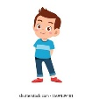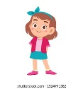Boy Clipart PNG, Transparent Boy Clipart PNG Image Free Download - PNGkey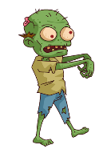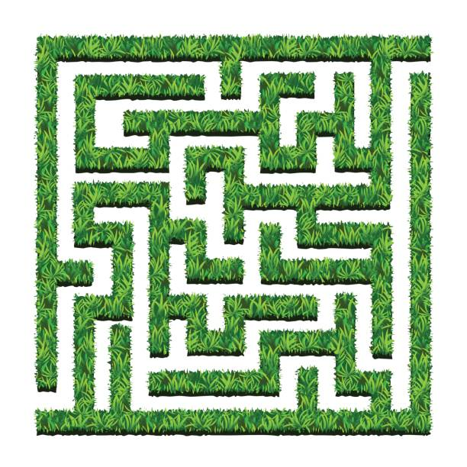

How do you plan to make your game engaging?

1.Using Animation

2. Incresing Difficulty Level

3. Adding sounds

4.Score.

5.Attractive